**Encryption**

To use encryption methods, users should include the following library: **codecrypt-win32-master**.

In the following photo we link ccr.exe file of encryption library

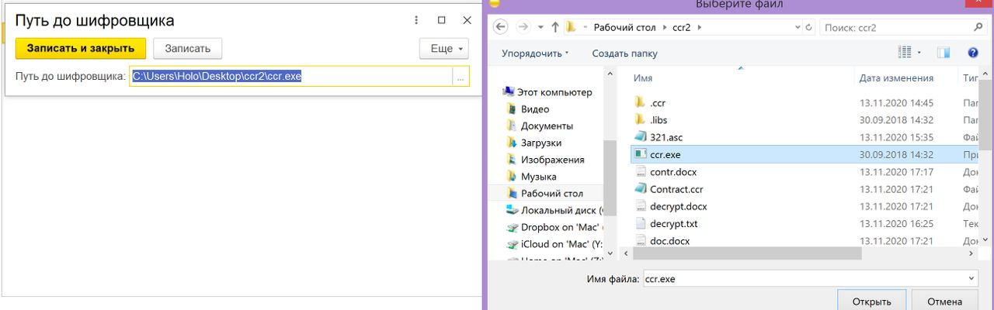

!!!To let 1C work with encryption, user needs link ccr.exe

Working with encryption are materialized in 2 places: Catalog «Пользователи» and Document «Заказ клиента». And other base objects (reciepts for payment, signs the contract) work with other services so we can’t control their method of encryption

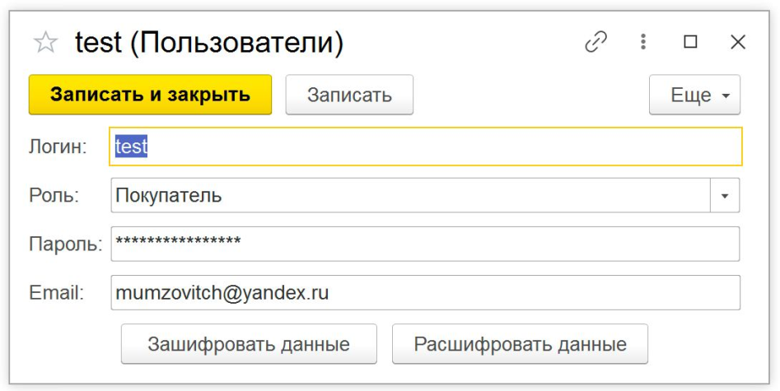

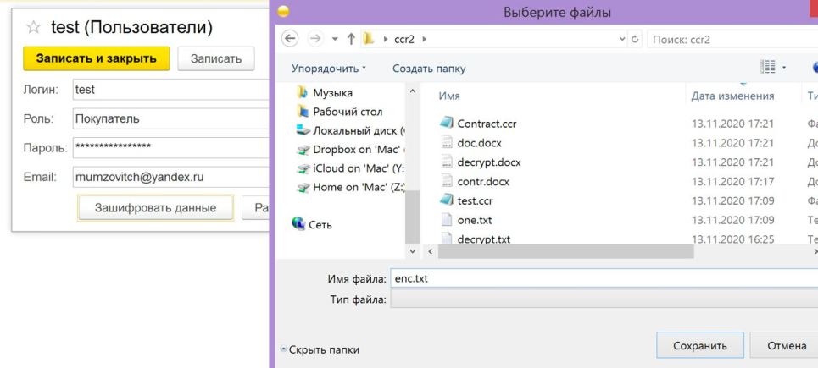

To encrypt login and password, user have to:

1. Click «Зашифровать данные»
2. Choose place and name to save login and password in file
3. Automatically creates the encrypted copy of this file (in task was marked to use methods of encryption, but wasn’t marked the way to use; and a decision was made to save file in storage) Encrypted file has name: «user_login»

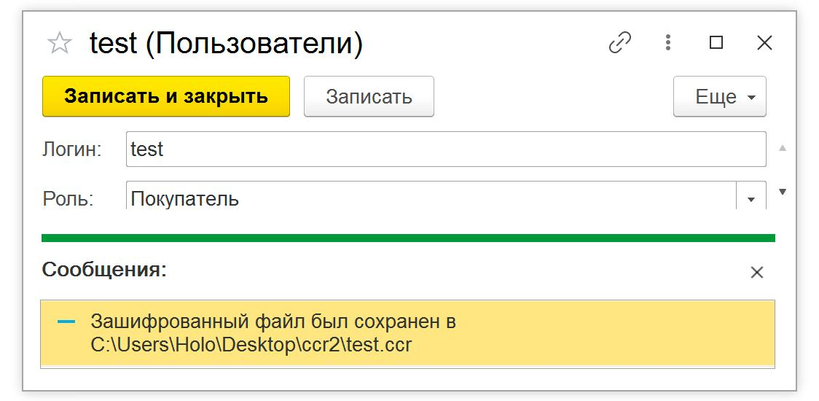

To decrypt user needs:

1. Click «Расшифровать данные»

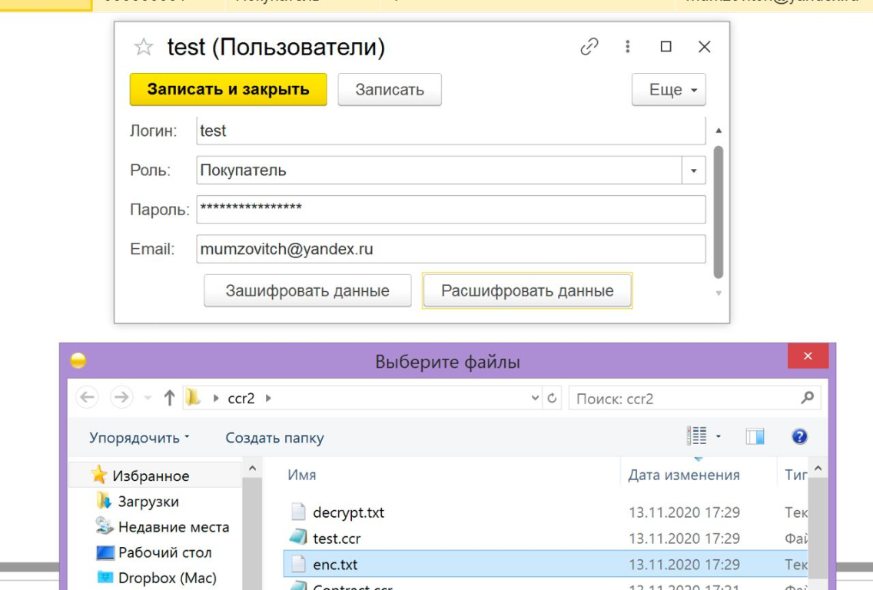

1. Choose encrypted file
2. After creates the decrypted copy of encrypted file

**Encryption of contracts**

It works the same way as Catalog «Пользователи»

